Neha Maddali and Jillian Egland

Problem 2:

1. The columns are the models M1, M2, M3, M4, M5. The rows are the 5 predicted values

> pred1[1:5]

[1] 7.559240 7.438056 7.504140 7.539358 7.415642

> pred2[1:5]

[1] 6.293302 6.308767 6.479241 6.359311 6.411642

> pred3[1:5]

[1] 6.323219 6.390942 6.512884 6.407827 6.463554

> pred4[1:5]

[1] 6.269641 6.668993 6.553530 6.360533 6.315840

> pred5[1:5]

[1] 6.433107 6.626336 6.664579 6.454152 6.313504

1. 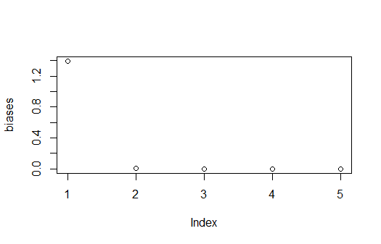
2. Here are the variance results

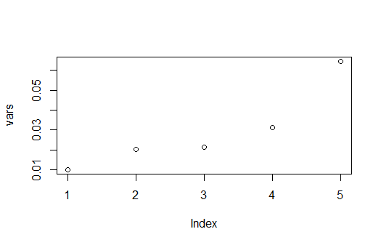

1. The irreducible error is approximately 0 because the error is generated from a normal distribution with mean 0 and standard deviation 1.
2. Model 1-5 test MSE:  
   1.401747, 0.02444239, 0.02152363, 0.03140206, 0.06449083
3. Bias(fhat(x0)): we were calculating the squared bias for different models at a specific point (x=0.9) to assess how well each model captures the underlying population pattern. Var(fhat(x0)) refers to the variance of the estimated or predicted values produced by the model at a specific point x. As model complexity increases, bias squared decreases, and variance increases.
4. Irreducible error estimates for the 5 models:

14.01747, 0.2444239, 0.2152363, 0.3140206, 0.6449083